Conservation & Tourism in the Gombong Karst

Petruk from the Wayang Kulit | 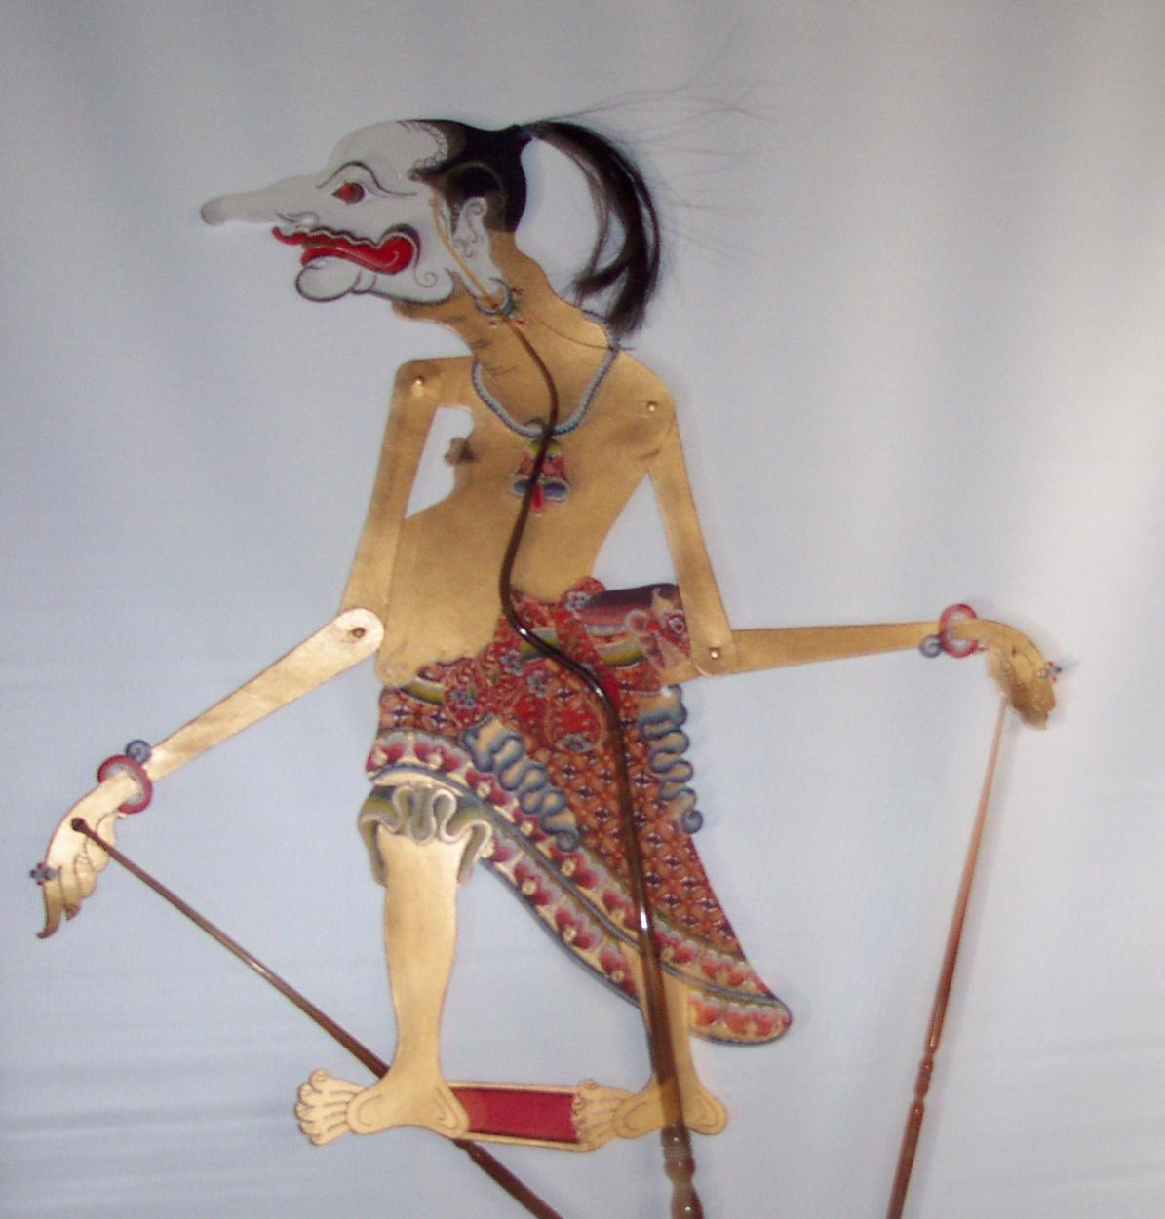
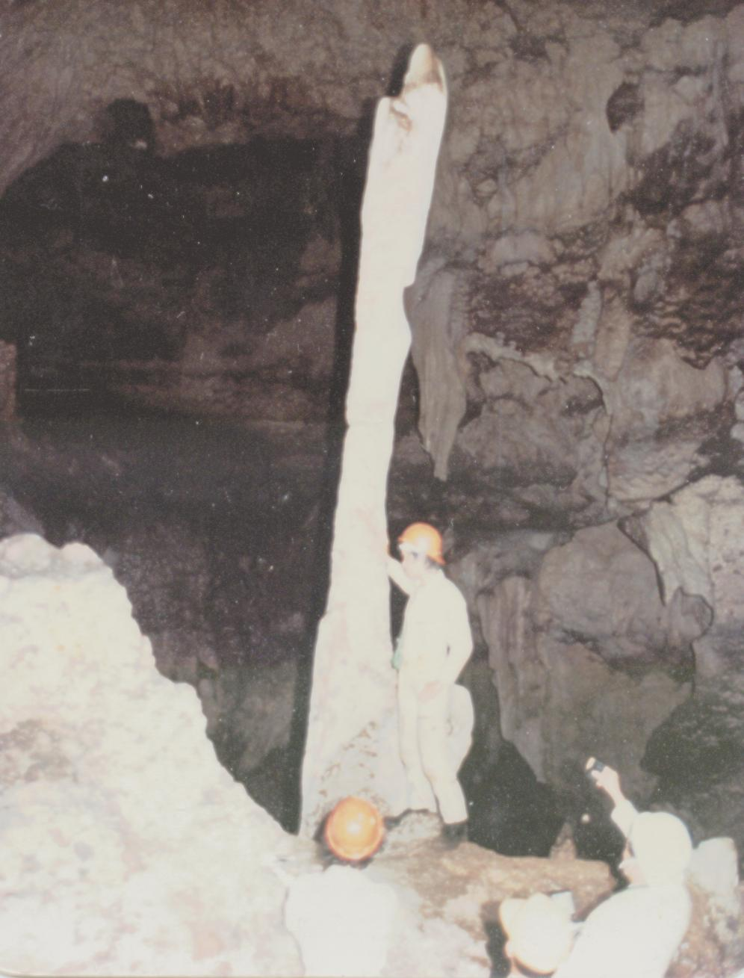 | Petruk in the Cave

Elery Hamilton-Smith, AM

IUCN / WCPA Task Force on Caves and Karst
June 2004.

